Calgary Custom Exteriors

*Site Organization*  
  
The CCE site will be organized into four sections.

**1.    About Us DONE**

a.     Comprehensive service, everything exterior.

b.     Family owned and operated, no subcontractors.

c.      Serves Calgary and surrounding area.

d.     Educate the customer about project, product, and maintenance.

e.     Quality exceeds industry standards.

f.      Maybe some of the discounts they are offering could go on the homepage here? Rich could make a couple cool icons that when clicked on open up a page with the details? I will write little catchphrases about them?

**2.    Products and Services NEED INSURANCE STUFF**

a.     Roofing, siding, and eaves troughs (complete exterior solns)

b.     About our favorite suppliers, links to their sites

c.      Servicesàinsurance claims, renovations…one stop for exterior needs.

**3.    Media Centre JORDAN**

a.     Photo gallery - Blake takes the lead on this.

b.     Testimonials—true stories. Blake take the lead on this.

c.      Links to other websites not included under products and services (like ECCO sustainability, IKO).

**4.    Contact DONE**

a.     Information about Jamie and family

b.     General contact info (email, phone, fax)

**1) About Us**  
Calgary Custom Exteriors is a family owned and operated company offering comprehensive and trustworthy service to the Calgary area. We are the only call you need to make, as we exceed industry standards for roofing, siding, eavestrough repair and renovation. Instead of subcontracting work for projects, our team of experts takes a hands-on approach, ensuring quality results and satisfied, informed customers. At Calgary Custom Exteriors our focus is on passing our knowledge of all things exterior to you, so that you can enjoy the quality of our craftsmanship for years to come.   
  
Rich, should this be shorter or longer to fit nicely in the space? I said everything he wanted me to on the outline, so hopefully it’s a good length.   
  
  
  
**2) Products and Services**  
Perhaps the products section should be separated into three parts, one each for siding, roofing, and eaves?  
  
Roofing  
link roofing products can lead here.  
He lists three different brands  
IKO  
<http://www.iko.com/products/residential/residentialall.asp>  
Malarkey  
<http://www.malarkeyroofing.com/wp3/malarkey-distributors/canada-distribution-2/#/20/shingle-color-selector/>  
BP  
<http://www.bpcan.com/en-CA/products/residential-roofing/asphalt-roofing-shingles/>  
  
those are the links to the specific shingles that the companies he listed offer in Canada, how do you want to put that on his website? I think that’s above my clearance level haha.  
  
He wants to be able to scroll over different shingle colors.  
  
Siding  
  
the link siding options can lead here.  
  
I think he wants to focus on aluminum siding…  
THESE ARE THE THREE SAMPLES THAT JORDAN NEEDS TO PUT ON!!!!!!   
Royal—Alumipro  
http://www.royalbuildingproducts.com/products/siding-and-exterior.aspx#  
Kaycan - push this one.  
<http://www.kaycan.com/?page_id=61>  
James Hardie—Fiber Cement…he wants us to list all colors for this too.  
<http://www.jameshardie.ca/EN/products_what_is_JHSiding.html>  
  
No specific products listed for eaves trough…  
  
And then there will be a little blurb about what CCE offers in each of those three areas.  
  
  
**SEARCH ENGINE OPTIMIZATION**  
  
Neota Corp. will conduct a study on the current market/competition in the exteriors business in Calgary, as well as any other markets in which Calgary Custom Exteriors would like to increase its relevance. Once this study is complete, Neota will help Calgary Custom Exteriors analyze how to most effectively attract new customers through search engine optimization.    
  
Cost: Will be quoted on upon further research.  
  
  
**Basic overview and theory:**  
  
Search engine optimization (SEO) is the process of improving the visibility of a website or web page in search engines via the "natural" or unpaid search results.  We also refer to these results as "organic" or "algorithmic". In general, the earlier and more frequently a site appears in the search results list, the more visits it will receive from the search engine's users. Below is an example of a Search Engine Results Page (SERP) in your industry, “roofing repairs calgary”  
INSERT SEARCH SCREENSHOT HERE  
The web links at the top of the screen shot are what we refer to as the natural or “organic” results.  Market research shows that strong organic rankings have a tremendous effect on click through rate (the number of people who proceed to the site).  
  
It is absolutely critical to note  NO ONE can legitimately guarantee first place positioning on the Search Engine Results Page (SERP). The purpose of this Search Engine Optimization strategy is to build your site in the most effective and aggressive manner possible so that Google will be able to acknowledge and adjudicate its relevancy, establish its ranking for the page, and as more people visit the site, this will in turn push up the SERP ranking of the site even more.  
  
Google has a method of ranking web sites that is extremely complicated, but our experience with the various search engines has shown us which elements of the site need to have the most emphasis placed on them. Search Engine Optimization is a crucial way of getting your information in front of the right audience the moment they are looking for services that you offer.    
  
Although Google and other search engines keep their ranking algorithms confidential, they do let us know about 180 points that they judge sites on and we have studied that and can apply it to your web presence. These are called the Pillars of the SERP. The most heavily weighted criteria that we’ve found to have a critical impact on the ranking on the website are the following:

1. Page Ranking - A nominal score that Google uses to rank your site
2. Rich Relevant Content - Content that is directly related to the search string and provides an abundance of reliable and trustworthy information
3. On-Site Optimization - The on-site adjustments/amendments that have to be made to make sure the site is search engine friendly (Title Tags, Meta Keywords, Meta Description, etc.)
4. Regular Updates in Content - Updating your content on a regular basis will encourage not only visitors, but also search engine spiders to visit your site more frequently.
5. Inbound and Outbound Links with other highly ranked sites.
6. User Generated Content - Google favors sites that value user input as it offers an abundance of relevant content
7. Age of URL

The SEO Program we offer covers 3 main components.  
  
Part 1:  Web Site Analysis, Amendment and Maintenance  
  
Regular changes on a website are an integral component of an SEO program. However our work with Google analytics ensures that we are making changes with a purpose.  To simply count the number of visitors to the site is an inaccurate method of measuring the site’s effectiveness. With our reporting using the Google Analytics tool, we can monitor exactly what people are doing when they get to the site. We analyze the keywords that visitors use to find the site, what additional pages they look up when they arrive, the path they take to get to certain pages, which pages on the site have more/less traffic, and whether or not they are STAYING when they arrive at your site (a crucial  factor to measure client interest in the site).  
  
Web Site Analysis will ensure that we are taking the proper steps to ensure that potential customers are finding exactly what they are looking for without bouncing out of the site right away. The better the presentation of information on the site the more likely the chance of purchase. We also use this tool to ensure that all the pages of the site are serving a purpose by analyzing whether people are clicking on a link or not. If a link is not enticing enough to click on, then we may need to change something with regards to that specific link in order to increase the traffic to that part of the site. This component of the SEO program is very analysis-intensive, and requires an expert eye to determine what changes need to be made to improve/continue the site’s success.  
  
Below is a snapshot of how many visitors arrive to an example site in a month, how many of them are unique (first time) visitors, how many of the pages from your site are viewed in total, how many pages people view per visit, how long on average people stay on your site, and how many people land on your site and leave right away. Obviously our intention is to minimize the bounce rate.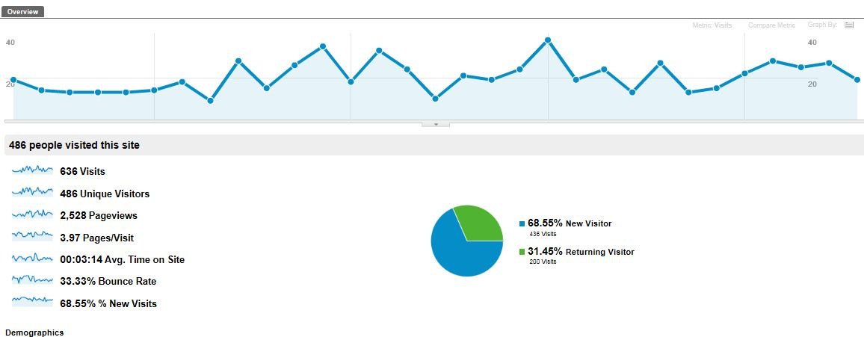  
Below is a snapshot of a flowchart that describes where people are coming from to land on your site, where they are going once they land on your site, which links draw the most/least attention, and how many people are “dropping off” when they get to a certain link. These and many other tools available in Google Analytics help determine what changes need to be made in order to promote the exposure of the site, and at the end of the day, generate sales for your business.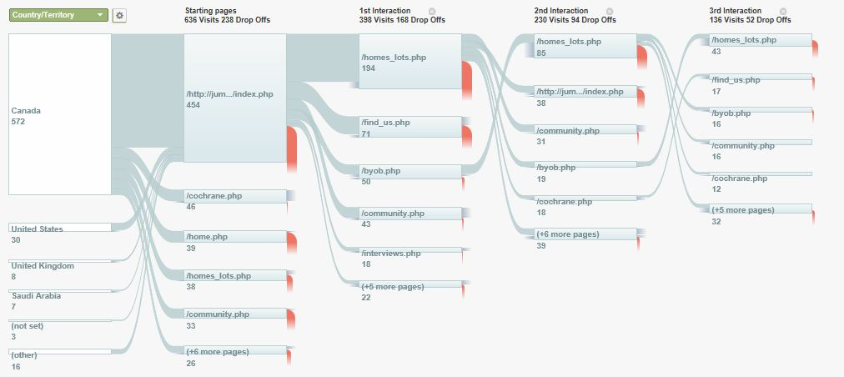  
  
  
Roofing  
Calgary Custom Exteriors offers a wide range of roofing products, all with one thing in common, unsurpassed Canadian quality. What sets us apart is our attention to detail; our roofing experts do not cut any corners when ensuring that your new roof is weather-proof and big on curb appeal. With lots of experience in new roofs, re-roofs, repairs and renovations, you can count on Calgary Custom Exteriors for a flawless finished product over your head. Browse our roofing products to see your options.  
  
Siding  
No one wants to spend time on phone calling different companies, installers, and suppliers, just trying to get work started on a siding renovation or repair. Calgary Custom Exteriors offers a solution to this problem; our expert tradespeople take care of every detail of your siding needs, while educating you about the process. Whether you desire stucco, vinyl, cedar, or fiber cement siding, we have the high-caliber products to meet your needs. Additionally, our siding experts have vast experience with soffit, fascia, and battens and an eye for detail…we’re ready to start and finish your project! See the wide range of siding options available to you.  
  
Other Products  
In addition to our extensive roofing and siding options, at Calgary Custom Exteriors we also offer excellent window and door installation; gutter cleaning; and in keeping with our commitment to reducing our environmental footprint, energy efficient insulation.  Furthermore, we install decks; fences; and custom wrought-iron gates, railings, and balconies.   
  
  
Information for the Contact Us page.  
  
Dusty - siding for 15 years, ran his own company with 12 crews working for him, major contractor for cardel homes been around calgary his whole life.  
  
Dylan - eavestroughing for years, another one of those people that knows everything.   
  
Jamie - started roofing when he was 17, roofed in the summers and then full time 9 years ago, incorporated five years ago, been around awhile, values his relationships with long-term customers and honesty, loves working outside, proud of a perfectly completed project - keeps him motivated, sincerely values customer satisfaction.